LCCS 6
Patrick Brennan
Mini Microbit Project
LCCS 6
Microbit Project

Contents
Part 1
{Part 1a} Preparing the Microbit to send Temperature data over a Serial USB port on your computer {MakeCode}
{Part 1b} Writing a Python program to read in the data from the Microbit and display in Thonny
Folder Setup
1. In your Documents folder create a new folder called: Microbit-To-CSV.
2. When your exercise is finished and working, you will have these 5 files.
Note: File. 4. Returns Cleaned Temp Data in .csv.py contains ALL the code.
Note: File temperatures.csv is automatically created by Thonny. You don’t need to make it.
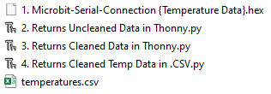
Note: You already have the first THREE files from another class.
You are beginning at 4. Returns Cleaned Temp Data in .csv.py

3. When completed and working, drag the whole folder called: Microbit-To-CSV to your OneDrive as part of your project material.

Serial Microbit Firebase Connection
What is this exercise about?
Uploading data FROM a Microbit up through a serial port and displaying in Thonny using Python
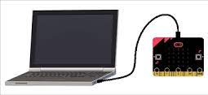

Note: A microbit does not automatically assume that you are connecting it to a USB port. We have to explicitly tell it so. This is even though a USB port and a microbit communicate using a Serial connection.

Part 1 {Capturing and Uploading the data}

USB Connection to Emulate SERIAL Communication
Step 1: From the Serial toolbox, drag out a serial block and stick it in the on start block.
- Redirect both connections to USB
- Set the baud rate to 115200 {rate at which the ‘bits’ are transferred over serial connection}
The baud rate is the rate at which information is transferred in a communication channel in bits per second.

Step 2: Drag a serial write number into the forever block.
- Add a Temperature block to it.
- Add a serial write line block beneath the previous block.
We will put speech marks here with a space. This is insert a blank line between our temperature readings to make it more readable.
- The show number and temperature blocks show the temperature on the Microbit.
- The pause of 5000ms or 5 seconds only allow the temperature to be read into the Python program in Thonny every 5 seconds.
- Download this code to the Microbit.
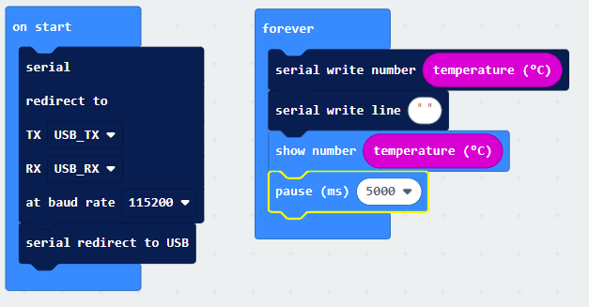

When we transfer this MakeCode ‘code’ to our Microbit by dragging it, we are emulating or creating a virtual port connection that allows the USB interface to function as a traditional {physical port} serial port connection.

A little about Ports
Serial Port: It is called a serial port because it ‘serializes’ the data. That means that it sends it one bit at a time. It uses only one wire to do this.
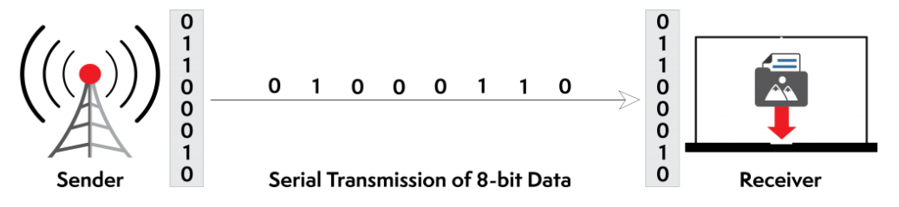
Note: A bit is only sent if the previous data bit has been received.
Parallel Port: A 8-bit parallel port is eight times faster because it uses eight wires – running in parallel - to transfer data.
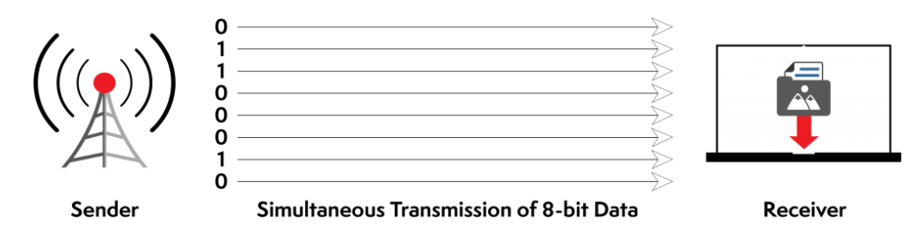

Universal Serial Bus (USB) is a SERIAL Communication Interface:
USB 2.0 | Hi-Speed USB | 480 Mbps
USB 3.2 Gen 1 | USB 3.0 USB 3.1 Gen 1 SuperSpeed | 5 Gbps
USB 3.2 Gen 2 | USB 3.1 USB 3.1 Gen 2 SuperSpeed+ SuperSpeed | 10Gbps

1. We use a ‘serial over USB’ connection because it allows data to travel one bit at a time, similar to a traditional serial port {which was physical port}.
It uses flow control to prevent the microbit or computer from being overwhelmed when transferring continuous data, such as temperature readings from a sensor.
Note: USB is already a serial communication port {like the Microbit}. What we’re doing is emulating or creating a virtual port connection that allows the USB interface to function as a traditional {physical port} serial port connection.

Note: In the code below, you will have to find the correct port that your microbit is connected to.
You do this by opening Command Prompt on your machine and typing: mode
{Part 1b}
Python program to read in the data from the Microbit and display in Thonny
Please note that this will import ‘uncleaned data’.
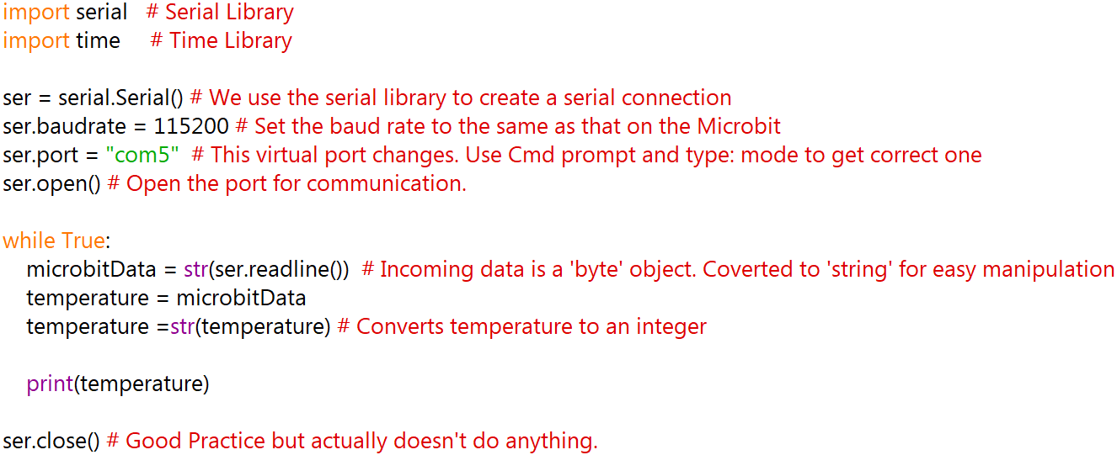

Return Data in Thonny Realtime

Please note that this will import ‘cleaned data’.

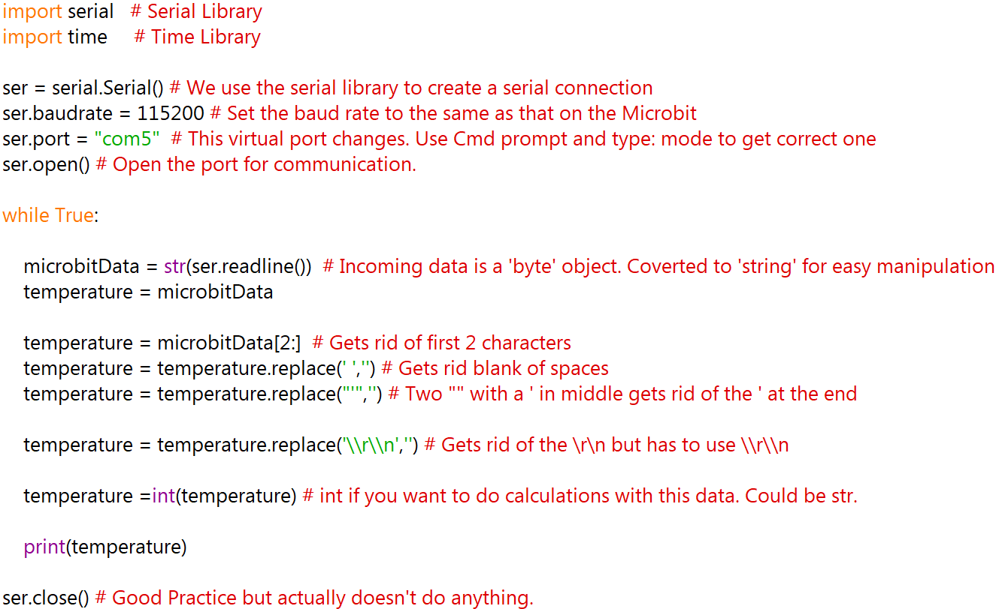

Return Cleaned Data in a .csv file

